How to Access Team Shop and Hard Goods
- Go to https://www.team.shop/en-us
- Enter the custom Access Code for your Team’s shop.
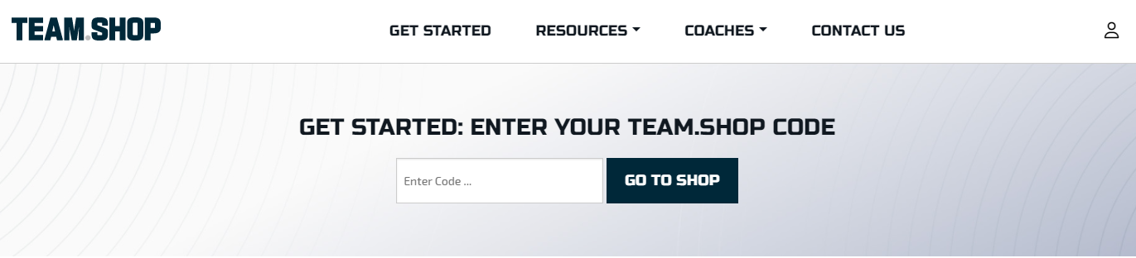
- Fill out Account Information
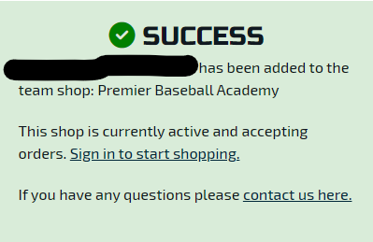
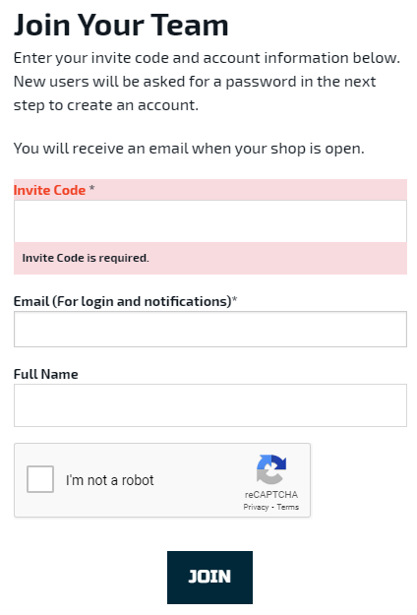
- Click “Sign in to start shopping” on the Success Page

- Sign into your Team.Shop Account. If you do not already have an account, click “Register” to create your account.
- After signing in, click “Start Shopping” on the shop you’d like to access. Once in the store, you will see your Team’s Custom Fanwear or Uniform Items
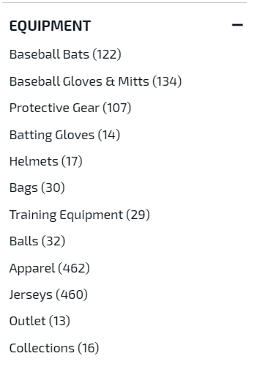
- 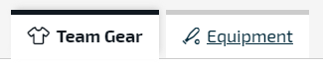To access your Team’s exclusive Bat, Glove, Evoshield Protective gear, and other hard goods discount, click “Equipment” at the top of the page or on the left side of the page.
- Shop the best Brands in Baseball and Softball with your exclusive discount!
Note: Equipment discount is available year-round!

